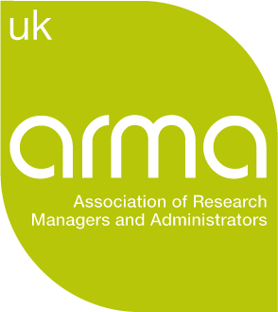 Post-Award SIG: Chair / Champion Opportunity

The Special Interest Groups (SIGs) are a core part of ARMA membership, and offer a means to connect with others working in similar areas. Over the last few months, ARMA has been reviewing how to further support members through the SIGs, and we’re now looking to extend opportunities for activities such as regional or ‘hot topic’ events, alongside building website provision.

With over 450 members, the Post-Award SIG is a significant community, and represents not only those in post-award roles but those in pre-award and other areas of our profession too.

We are looking for a dynamic and enthusiastic member to take charge of the Post-Award SIG. We're looking for a people person, someone with ideas, a team-builder who can enthuse, inspire, excite and even challenge. Someone to review and develop our Post-Award SIG offering, support the enhancement of resources for our Post-Award community, someone who can lead virtual or face-to-face meetings, and help coordinate ongoing SIG work such as responding to sector consultations. We're not looking for a post-award genius, but if you happen to be one, don't let us put you off!

We are therefore inviting expressions of interest for a new Champion, with the role running for 12 months in the first instance. If you’re interested, please send a short CV and a brief cover note by email
outlining:
- Why you are interested in the role
- What would you do with the role
- Your key skills/experience which could support SIG activities and development
Please send your short CV and cover email to nicole@arma.ac.uk by 9am on Tuesday 14 May.

If you would like to discuss the role further, please contact hamish.macandrew@arma.ac.uk to fix up an informal telephone call

Click here for the terms of reference for a SIG Champion and the Post-Award SIG.

