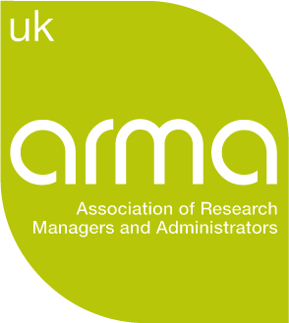

Research Contracts SIG: Co-Chair Opportunity

The Special Interest Groups (SIGs) are a core part of ARMA membership and offer a means to connect with others working in similar areas. Over the last few months, ARMA has been reviewing how to further support members through the SIGs, and we’re now looking to extend opportunities for activities such as regional or ‘hot topic’ events, alongside building website provision.

With over 390 members, the Research Contracts SIG is a sizeable community, and represents research professionals not only in traditional contracts management roles but those in pre-award, post award and audit/compliance roles too.

The Research Contracts SIG is currently led by Sapna Marwaha but, with activity on the increase, Sapna is now looking for new co-champion. The co-champion would work with Sapna to review and strengthen current provision, support extension of the website and resources, and help coordinate ongoing SIG work such as information-sharing events.

We are therefore inviting expressions of interest for a new champion, with the role running for 12 months in the first instance. If you’re interested, please send a short CV and a brief cover note by email outlining:
- Why you are interested in the role
- Your key skills/experience which could support SIG activities and development
Please send your short CV and cover email to nicole@arma.ac.uk by 9am on Tuesday 14 May.

If you would like to discuss the role further, please contact Sapna Marwaha at sapna.marwaha@nottingham.ac.uk.

Click here for the terms of reference for a SIG Champion and the Research Contracts SIG group.

