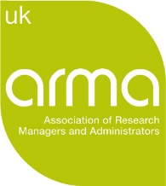


INORMS 2020 Travel Award Application
First Name:
Last Name:
Organisation:
Address:
Country:
Postal Code:
Email Address:
Have you attended an INORMS Congress before? Yes/ No
Are you a member of ARMA? Yes / No

Please provide a document outlining the following (maximum of 2 pages):
- An explanation of why you wish to apply for an ARMA-INORMS 2020 Travel Award.
- Describe how attending INORMS is relevant to your current role and responsibilities in the organisation and how it aligns with your career plan.
- Describe how others in your organisation will be able to benefit from your attendance at INORMS.
- If you are able to, provide evidence that you would be unable to attend the Congress without a bursary.
- Provide an itemised travel and accommodation budget, briefly narrating each line item. This budget may exceed £1,000, in which case ARMA will provide a contribution not exceeding this sum.

Please remember to attach your Letter of Support or Self-Employment Statement.

